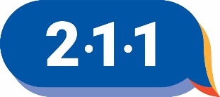
UNITED WAY 211 AGENCY FORM
Complete all applicable information on this form. You may attach brochures or other documentation which may aid in a better understanding of services provided. Please type or print carefully.
EMAIL completed form to: dtipton@unitedwayplains.org . ATTACH a copy of your IRS 501(c) status (if applicable).
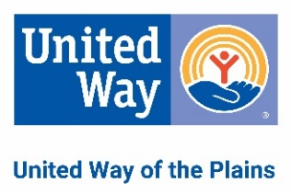
Date: May 23, 2023
Agency Name: Ark City Church of the Nazarene
Address (Street, City, State, ZIP): 1928 N 11th St , Arkansas City, KS
Mailing Address (if different):
Email: Website:
Phone: Alt. Phone:
Fax: 24 hr or 8YY:
Person in Charge: Title:
Contact Person: Title:
*Communicates with 211 for listing updates
Hours:
Agency Type (check one):
o Government o Profit
o Religious o Private, Non-Profit
o Volunteer o Public, Non-Profit
Purpose:
Handicap Access? o Yes o No
Person Completing This Form:

