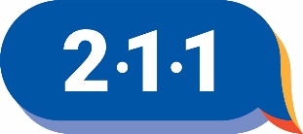
UNITED WAY 211 PROGRAM FORM
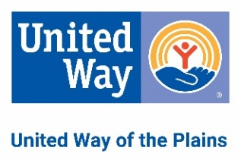
Complete all applicable information on this form. You may attach brochures or other documentation which may aid in a better understanding of services provided. EMAIL completed form to: hpierce@unitedwayplains.org
Program Name:
Purpose:

Fees:
Languages:
Intake Procedure:
Eligibility Requirements:
Services Offered (Be as specific as possible. Use additional space as necessary. NOTE – Callers are referred to your program based on this description.):

Handicap Access? o Yes o No Area Served (e.g., Butler County):
Funding (e.g., government, donations):
Only complete the information below that is different than the AGENCY information.
Hours:
Person in Charge: Title:
Address (Street, City, State, ZIP):
Email: Website:
Phone: Alt. Phone:
Fax: 24 hr or 8YY:
Person Completing This Form: Date:

